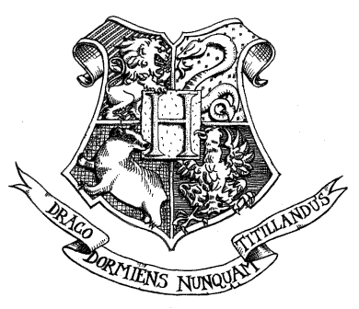

HOGWARTS SCHOOL OF WITCHCRAFT AND WIZARDRY

Headmaster: Albus Dumbledore
(Order of Merlin, First Class, Grand Sorc., Chf. Warlock,
Supreme Mugwump, International Confed. of Wizards)

Dear Mr Potter,

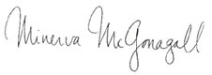
Term begins on 1 September. We await your owl by no later than 31 July.

and Wizardry. Please find enclosed a list of all your necessary books and equipment.

We are pleased to inform you that you have a place at Hogwarts School of Witchcraft
Yours sincerely,
Minerva McGonagall
Deputy Headmistress

