Salt Dough Recipe for Crown of Thorns

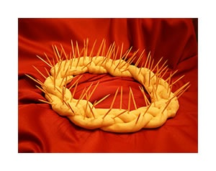
This simple recipe can be used for Christmas ornaments as well as the Lenten project mentioned by Stacy Mitch in her article “Hearts at Home: Living the Liturgy as Preparation for Our Heavenly Home” in the November/December ’06 issue of Lay Witness.

On Ash Wednesday, follow the instructions below to make a salt dough crown of thorns with your children, anticipating Lenten sacrifices your family hopes to make. Place the crown in a prominent place in your home; it makes an excellent centerpiece for your dining room table, and placing it upon a royal purple cloth has a striking effect.

For each Lenten sacrifice a family member makes, he or she pulls a toothpick out of the crown. This activity makes a great visual reminder of Christ’s suffering: Parents can explain to their children that sin brings additional pain to Jesus’ suffering and good works can comfort Him and show our love for Him.

The goal should be to remove all “thorns” from the crown by Easter. Once all the “thorns” have been removed, you can paint the crown gold or otherwise decorate it with colorful craft jewels, beads, or flowers where the “thorns” once were as a sign of the triumph of our risen King. This makes a beautiful Easter Sunday centerpiece with a great story to share with your guests.

Materials:

4 c. flour
1 c. salt
Water
Toothpicks
Pam (or some other non-stick spray)

Directions:

Mix flour and salt. Mix enough water to make a stiff clay. (A little warmth helps dissolve the salt.) Knead until smooth to remove any air bubbles. Roll three long ropes and loosely braid them. Form braid into a circle and stick toothpicks that have one end saturated in Pam loosely throughout the entire crown (If they are embedded too deeply they cannot be pulled out intact.) Bake at 350° F for an hour or until it is dry and light brown.

